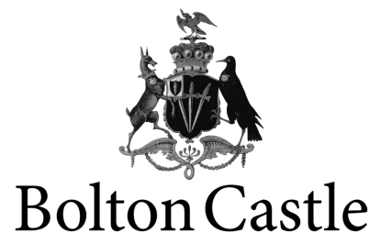

School Visit Booking Form
Contacting You
Name of School: _____________________________
Name of Teacher : Title: ______ First Name: _______________ Last Name: _______ Post Nominal’s____
Address of School : _____________________
_______________________ Telephone no: ___________________
_______________________
___________________
Post code: _____________________ Email address:_______________________

About your visit
Date of Visit: ______________ Mobile number of Lead Teacher during visit: _______________________
Arrival Method (coach, minibus etc) ________________________ No of Coaches: __________________
Group Arrival Time: ___________________ Group Departure Time: _________________________

About your Group
Total Number Expected: ____________________ Age range of Group: ____________________
Any other Information: (Please indicate if you have any special requirements or if there is anything you feel we need to know in order to give your group the best possible experience.)______________________________________________
__________________________________________________________________________________________________

Type of Visit Requested (Please tick)
Full Activity Day (£13.50): ___
Themed Guided tour and Teacher Led activities (£9): ____ Castle Entrance only (£6.00): _____
Theme or Topic studied: _________________

For visits with teacher-led activities, please tick which activities you would like to do;
Pomander making _________ Period Dancing _______ Costume Collages ______
Plague bag making __________ Period Toys and games _______ Artefact Sketching _____
Calligraphy ___________ Gods Eye Making (Older students) ______

Medieval Banquet: (£6.50 a head) ______ Packed Lunch: ______

How did you hear about us? (please tick)
Castle Leaflet O Word of Mouth O
Bolton Castle Website O Other website (please specify) ___________________
School booking pack O Advert in Magazine/Newspaper
Local to area O (Please specify) _____________________________

Data Protection
We would like to keep your details on file so we can keep you updated on special offers and new developments at Bolton Castle. This will also enable us to monitor school bookings at the Castle. We promise that any information you give will be used for this purpose only by Bolton Castle and will not be passed to any other company. We need your consent to hold your personal details to fulfill our obligations under the Data Protection Act.
I hereby give consent for my information to be used in the manner detailed above. I am happy to be contacted by (please tick the appropriate box)
By Post [ ] By Email [ ]
Signature ____________________________________

Additional Information
Please complete all relevant information as this will help our staff run a successful day for you and is essential for Health and Safety procedures.
Please return along with your booking form to confirm your booking.

- Is there anyone in your group with mobility problems? i.e. wheelchairs/walking difficulties ( there are stairs throughout the building and we do not have a lift) Please detail;
______________________________________________________________________________________________________________________________________________________________________________________

- Do you have any children with behavior problems such as attention disorders? Please detail;
______________________________________________________________________________________________________________________________________________________________________________________

- Do you have any children who are prone to any serious allergies of any sort? Please detail;
______________________________________________________________________________________________________________________________________________________________________________________

- If you are having a medieval lunch provided by the Castle please let us know of any children who have any medical or religious dietary requirements. Please detail;
______________________________________________________________________________________________________________________________________________________________________________________

- Any other additional needs not covered above? Please detail;
______________________________________________________________________________________________________________________________________________________________________________________

Please return this form by email to Dave Manning on dave@timetalks.org.uk
If you need any further information or have any questions on this form you can contact Dave on the email address above or on 07951956553

If any of the above details change between you confirming the booking and the day of your visit please inform us a soon as possible. Please confirm the change in writing by email.

