Information for School Visits 2016
Planning your visit to Bolton Castle

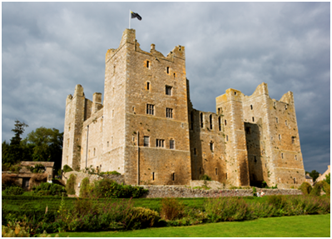
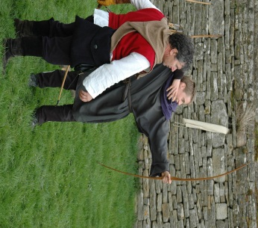
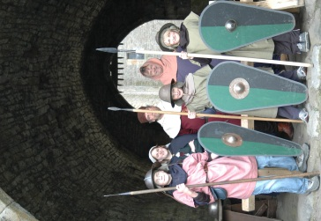
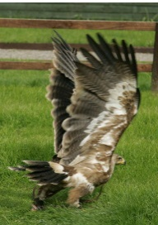

Thank you for your interest in School Visits and Activity Days at Bolton Castle.
The following information is designed to help you plan a successful visit, however if you have any more specific questions please don’t hesitate to contact us before completing the enclosed booking form.

Background History
Bolton Castle is a spectacular medieval fortress situated in the heart of Wensleydale.
Completed by Sir Richard Le Scrope, in 1399, its scars bear testament to more than 600 years of fascinating history making it an ideal venue for educational school visits covering topics from Medieval life to the English Civil War. The authentic and atmospheric room displays show Castle life as it would have been for the different members of the Castle community from the archers, cooks and monks to Mary, Queen of Scots and Lord and Lady Scrope.

Educational Visits
We are now offering an exciting range of opportunities for schools and youth groups to visit Bolton Castle and learn more about what castle life was really like for both rich and poor, the fascinating events that took place here and how much things have changed.

Different options for school visits include Full Activity Days, themed guided tours and teacher led activities and Castle only options.
Topics/themes currently offered include ‘Medieval life’, ‘Castle defences’, ‘Castle life’, ‘The Tudors’, ‘ The Stuarts’, ‘Mary, Queen of Scots’, ‘Rich and Poor’, ‘The Wars of the Roses’, and the ‘Civil War’.
We will do everything we can to ensure all guided tours and activities give your class the best possible learning experience by adapting our tours and activities to address the learning outcomes of your specific topic/theme, the age and ability of the group and any additional support needs you make us aware of.

Trouvere Medieval Minstrels
Trouvere are specialists in live historical presentation and present a fantastic range of historical workshops combining music, dance, role play and lots of fun!

Included in all school visits during our open season (February—October) is the chance for students to watch our falconry displays, enjoy the archery demonstration and visit the Wild Boar and Maze.

Out of season, students can still enjoy the castle, gardens and maze as well as visiting our wild boar but the falconry will not be available. Archery, spear and sword drill is included in a full activity day but not in other types of visit.

Falconry, Archery, Wild Boar, Rare Breed sheep and Bee Keeping.

Included in all types of school visit (during the open season (February—October) is the chance for students to watch the incredible falconry displays, enjoy the archery demonstration, visit the Wild Boar and see the Bees in their hives.

The range of displays available include;

Bird of Prey Displays
Enjoy a spectacular flying display from our hawks, owls and falcons.

Wild Boar Park

School groups may visit the boar at any time and, as the boar spend most of their time at the front of the park, you do have a good chance of seeing them. There is also a wild boar talk and feeding time each day.

Archery Demonstrations and Have a go!

Learn more about archery in sport, hunting and warfare during our displays and then have a go yourself! (Depending on size of group and members of the public in the Castle not all children may be able to have a go unless you have booked a Full Activity Day.

Bee Keeping Display (May—Sept)
Meet our bees in their observation hive and learn more about bee keeping through the ages by visiting the display in our bee house.

Please contact Dave Manning at dave@timetalks.org.uk or 07951956553 to discuss organising your visit.

School Visits and Activity Days Options

Full Activity Day

Cost: £13.00 a head (minimum 20 students) I free adult for every 10 children, extra adults £7.00 a head unless members of group have additional support needs in which case all support staff will have free entry.
Available Dates: All year round.
Timings: 10.00—15.00 (Times can be adjusted to suit school requirements)
Lunch Options:
1) Themed Banquet. We can lay on an authentic themed banquet consisting of for example bread, cheese, ham, eggs, chicken, flapjacks and more for £5.95 per child.
2) Packed Lunch—Children may bring their own packed lunch (preferably authentic to the day) which can be eaten in the Old Kitchen.
Entrance includes access to gardens and grounds.

Description.
Our Full Activity Days are led by an experienced living historian and give children the unique opportunity to live in a medieval castle, as their ancestors might have done. This is as close to time travel as possible and we believe it enables the children to not only learn on the day, but it also develops their interest and motivation in the classroom. This is achieved through an introductory talk, themed guided tour and a range of activities tailored to the topic/period being studied: spear drill, sword drill, calligraphy, handling and sketching artefacts, medieval toys and games, uses of herbs and pomander making, plague bag and pomander making, dancing and archery are all on offer. They will also have the chance to see the falconry displays and Wild Boar. We are able to provide authentic Medieval costumes, consisting of a tunic and cappucine/wimple, belt or rope tie and leather purse, and skirts, jackets and hats for the Tudor/Civil war period.

Themed Guided tour and Teacher- led Activity Day

Cost: £9.00 per child (minimum 20 children), adult entry as above.
Available Dates: All year
Timings: Any time between 10am and 5pm.
Lunch Options: as Above
Entrance Includes access to gardens and grounds.

Description
These school visits give your children a great introduction to the Castle with a fascinating guided tour and then the chance to experience a range of exciting themed activities.
Children start the experience by entering through the portcullis and receiving an introductory talk in the spectacular castle courtyard. They then have the opportunity to get into Medieval costume and enjoy a guided tour of the castle, watch the archery demonstration and the Bird of Prey display. After lunch they can enjoy their teacher led activities which can include pomander making, calligraphy, artefact sketching, plague bag making, costume collages, God’s Eye making, dancing and toys and games. We will provide all materials and instructions for teachers/leaders to be confident to lead these activities. Tour and activities will be tailored to the specific topic/theme being studied.

School Visits and Activity Days Options

Castle Entrance Only
Cost: £6.00 a head (minimum 15 students)
Available Dates and Times: During normal castle opening times
Lunch Options: As above.
Entrance includes access to gardens and grounds.
Description
This day allows you to explore the Castle with your group at your own pace and enjoy learning more about this incredible building. We recommend that you allow at least an hour to explore the Castle properly and also allow some time (approx 30 minutes) to enjoy our beautiful medieval gardens and maze which is always extremely popular. Children also get the chance to see the archery demonstration, watch the falconry displays and meet the Wild Boar and bees.
We can provide various activity sheets/trail s to add interest while the children explore the Castle with themes including Castle life, Tudors, Stuarts, and more.

Trouvère Medieval Minstrels
Musical Workshops
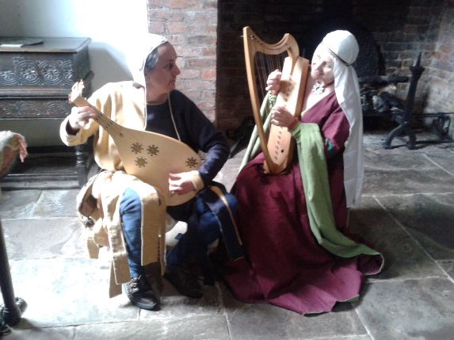

Trouvère Medieval Minstrels have been presenting workshops for schools for some ten years now. They started off specialising in the Tudor period, but have branched out to cover the Medieval Period as well and so are perfectly placed to provide workshops within Bolton Castle.

We are offering the incredible opportunity for schools to combine a visit to the Castle with a Medieval or Tudor workshop led by the wonderful Trouvère.

Options available include:
Castle entrance and one Trouvère workshop: £300 (max 30 children)
Castle entrance and two Trouvère workshops: £400 (max 30 children)

Workshops last 1.5 hours each so the children will also have time during the day to explore the Castle, enjoy one of our archery and falconry displays, get lost in the maze and meet the wild boar and have lunch in the Old Kitchen or gardens depending on the timings for your visit.
Trouvère will be available on Mondays and Tuesdays during school term time. Other days may be possible if you are unable to schedule for either of these days. Please enquire using the details below

Trouvère Tudor workshops available include:

An Audience with Mary Queen of Scots
Extended roleplay. The children meet the Queen, learn about Tudor behaviour and etiquette and try out for various posts at court. (Years 3-6)

Tudor Revels
A fun mixture of Tudor activities including have-a-go with Tudor musical instruments, playing Tudor games and an introduction to Tudor dance. (Years 3-4)

Tudor Music & Dance
Hearing and trying out a great variety of Tudor-period musical instruments plus learning Tudor dance steps and a simple dance. (Years 5-6)

Trouvere Medieval Workshops include:

In the Great Hall
In this session we explore the similarities and differences between medieval and modern life by focusing above all on how people had fun in the middle ages. The children get dressed up in simple medieval outfits and acquire a medieval name, before going on to learn some simple medieval greetings. They then try out medieval musical instruments, have a go at a variety of medieval games and try some medieval dancing - or as much of this as we can fit in! Suitable for KS1 and KS2

Medieval Music and Dance
A similar session but aimed at older KS2 (Years 5 and 6) with a larger instrumental component and no dressing up!

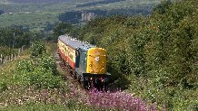
School Visits and Activity Days Other Information

Access
The gardens are accessible for wheel chairs, but please be aware that there are slopes and gravel paths which can become slippery in wet conditions.
Unfortunately due to the nature of the building the Castle is not wheelchair accessible and spiral stairs and
uneven flooring exist throughout the building. Please see our website for a full access statement or let us know if you would like a hard copy sent out to you.
Although we have a minimum group size we will make exceptions for groups of students with additional support needs who are only able to visit in small groups.

Health and Safety
We have completed risk assessments for all activities and Health and safety advice for school visits which we are happy to send out to you if you wish to see these. Alternatively if you wish to visit the Castle before your visit and gather some more information to make your own risk assessments we will happily offer you free entry and a chance to speak to a member of staff if you have any questions.

Coach Parking
There is space for coaches to park next to the Castle and on the road next to the village green adjacent to the Castle with a very short walk to the Castle entrance. We have spaces for up to three coaches to park at one time.

Arrival
To ensure a smooth and efficient admissions process we ask that the teacher leaves the group on the coach (or organises adults to take children to loos in car park if necessary) and makes their way to the admissions desk to meet the member of staff at the Castle. We will then be able to bring the group in through the portcullis and do a short welcome and health and safety briefing for the group.
Alternatively if you wish you can bring your group in through the normal visitor route through the trellis door opposite the church which takes you straight to the tea room and gift shop.

How to Book

To book please complete booking form and return to Dave Manning at dave@timetalks.org.uk or call Dave on 07951956553 for more information or to check available dates.

