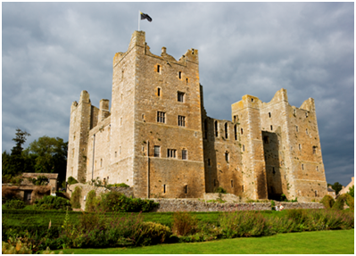
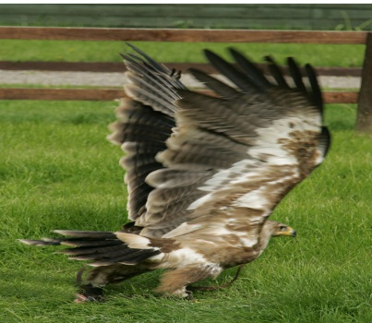
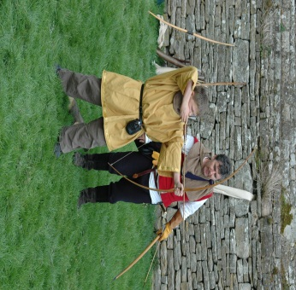
Information for Groups 2016
Planning your visit to Bolton Castle
Thank you for your interest in Bolton Castle.
The following information is designed to help you plan a successful visit, however if you have any more specific questions please don’t hesitate to contact us before completing the enclosed booking form.

Bolton Castle is one of the country’s best preserved medieval castles, situated in the heart of Wensleydale, with stunning views over the Yorkshire Dales National Park. Completed by Sir Richard Le Scrope, in 1399, its scars bear testament to more than 600 years of fascinating history including involvement in the Pilgrimage of Grace, Mary Queen of Scots imprisonment in 1568 and being held for the king in a six month siege during the Civil War. The Castle has never been sold and remains in the private ownership of Lord Bolton, Sir Richard le Scrope’s direct descendant.
Bolton Castle was a luxurious family home as well as a defensive fortress and despite being partially ‘slighted’ by Cromwells’ men during the Civil War the Castle is preserved in outstanding condition with many interesting rooms and features to discover including the Old Kitchens, Dungeon, Solar, Nursery, Armoury and Mary Queen of Scots bedroom giving visitors great insight into the Castles turbulent past.

The Ultimate Medieval Experience
As well as bringing more of the rooms back to life with some fantastic new displays we now have a Wild Boar Park, Falconry Experience and the opportunity to have a go at archery giving visitors the unique chance to experience more of what life was like in a castle, between the fourteenth and seventeenth centuries. Experience incredible flying displays in the Castle courtyard and gardens, learn about medieval archery and feed the boar!

New for 2012— Local rare breed sheep and audio-visual tour.
Come and visit our Wensleydales and other local rare breed sheep. Our newest arrivals at Bolton are a trio of Wensleydale ewes and we expect their lambs to be born in the spring so keep an eye on our website for news of their arrival!
Try our Audio – visual guides which will provide greater insight to the Castles turbulent past. Our new guides use the latest technology and can be enjoyed while exploring the castle but will also allow those less mobile to enjoy a virtual tour from the comfort of the castle tea room. Learn about the Scrope family who first built Bolton and whose direct descendants still own it today.
Group Visits
Adult groups and families might like to explore the extensive surviving rooms by themselves, or have a private tour by one of the enthusiastic and expert guides, focussing on Mary, Queen of Scots’ imprisonment or the Civil War, for example. For those seeking a more luxurious and less energetic visit, we can provide a delicious five course lunch in the Great Chamber, with a log fire blazing and exclusive use of this magnificent room. We can also provide fascinating illustrated talks on Mary Queen of Scots imprisonment, the Border Reivers, Medieval Hunting or the history of the Castle and its inhabitants.

Thank you for your interest in Bolton Castle.
The following information is designed to help you plan a successful visit, however if you have any more specific questions please don’t hesitate to contact us before completing the enclosed booking form.

Bolton Castle is one of the country’s best preserved medieval castles, situated in the heart of Wensleydale, with stunning views over the Yorkshire Dales National Park. Completed by Sir Richard Le Scrope, in 1399, its scars bear testament to more than 600 years of fascinating history including involvement in the Pilgrimage of Grace, Mary Queen of Scots imprisonment in 1568 and being held for the king in a six month siege during the Civil War. The Castle has never been sold and remains in the private ownership of Lord Bolton, Sir Richard le Scrope’s direct descendant.
Bolton Castle was a luxurious family home as well as a defensive fortress and despite being partially ‘slighted’ by Cromwells’ men during the Civil War the Castle is preserved in outstanding condition with many interesting rooms and features to discover including the Old Kitchens, Dungeon, Solar, Nursery, Armoury and Mary Queen of Scots bedroom giving visitors great insight into the Castles turbulent past.

The Ultimate Medieval Experience
As well as bringing more of the rooms back to life with some fantastic new displays we now have a Wild Boar Park, Falconry Experience and the opportunity to have a go at archery giving visitors the unique chance to experience more of what life was like in a castle, between the fourteenth and seventeenth centuries. Experience incredible flying displays in the Castle courtyard and gardens, learn about medieval archery and feed the boar!

Planning your day

Castle
We recommend that you allow at least an hour and a half to explore the Castle. Our excellent full colour guide book will take you on a self-guided tour of the castle revealing its fascinating history, including an introduction from the family, interesting facts about each room and a comprehensive timeline of historic events at the Castle.
(Alternatively there are information boards and cards in each room).
We offer a 50% group discount on our Guide Books reducing them to £1.50 per person.

Guided Tours
Your group might like to enjoy a private tour by one of our enthusiastic and expert guides.
Tours are available for groups of 15 or more at £2.00 per person (plus admission charge) and last for approximately an hour and a quarter. Guided tours must be booked in advance.

Illustrated Talks
We can also provide fascinating illustrated talks on Mary Queen of Scots imprisonment, the Border Reivers, Medieval Hunting or the history of the Castle and its inhabitants.
Illustrated talks must be booked in advance.

Gardens and Grounds
The gardens include a Vineyard, Herb Garden, Maze, Bowling Green and Rose Garden
as well as our newly created Mary Garden (Catholic Garden). Visit our new garden with displays of flowering plants traditionally associated with Our Lady such as her slippers, thimble, teardrops and her nightcap.
We suggest you allow at least half an hour to enjoy these fully. There are areas to picnic within the gardens.

New for 2016

Green Woodworking Workshop
Visit our new medieval workshop with pole lathes and green woodworking tools.

Falconry, Archery, Wild Boar, Rare Breed sheep and Bee Keeping.

Included in all types of group visit during the open season (February—October) is the chance to watch the incredible falconry displays, enjoy the archery demonstration, visit the Wild Boar and see the Bees in their hives. The range of displays available include;

Bird of Prey Displays (11.30 and 3pm daily in the gardens)
Enjoy a spectacular flying display from our hawks, owls and falcons. With different birds flying in each demonstration and a chance to meet our friendly owls.

Wild Boar Feeding and Talk (4pm daily at the Boar Pen)
Experience the excitement of Wild Boar feeding time! Learn more about these fascinating animals, and help us feed them.

Archery Demonstrations (1.45pm in the courtyard)
Learn more about archery in sport, hunting and warfare during our displays. Children can have a go depending on size of the group.

Local Rare Breed Sheep
Meet our friendly local rare breed Wensleydale sheep.

Bee Keeping Display (Usually May—Sept)
Meet our bees in their observation hive and learn more about bee keeping through the ages by visiting the display in our bee house.
Tea Room

Our Tea Room is open all day serving a variety of drinks and cakes, light lunches and afternoon teas and is situated in the atmospheric Guest Hall where visitors to the Castle have been served for over six hundred years.
If you are visiting with a group of 40 or more we ask that you split into two or more smaller groups to visit the tearoom, especially on busier days. We ask that large groups choose from the menu provided at the back of this pack before arrival to ensure the best possible service during your visit. Booking is essential.
Please contact our tea room caterers on 01969 625617 or 09169 624668 or email guyfairhurstcatering@gmail.com or Lorna Skelton on lornaskelton@yahoo.com

If you are looking for something really special we can provide a delicious five course lunch in the Great Chamber, with a log fire blazing and exclusive use of this magnificent room.

Wensleydale Railway
Combine your visit with a trip on the Wensleydale Railway and receive a 20% discount on your admission rate on top of your group discount. Please ask for more information.

Tea Room Group Menu
Please book your group into the tearoom in advance by calling 01969 625617 or 01969 624667 or emailing Guy Fairhurst at guyfairhurstcatering@gmail.com or Lorna Skelton on lornaskelton@yahoo.com

Tea or coffee and a fruit scone are charged at £3.50 per head

Menu 1
Savory Dill Scone with Horseradish Creme Fraiche and Smoked Salmon or Fresh Cream and Jam Scone with Strawberries
Open Yorkshire Ham Sandwich on Crusty Bread
Tea or Coffee
£5.95 per head

Menu 2
Individual Yorkshire Blue and broccoli quiche
Sausage Meal Plait with Onion Sage and Apple
A selection of closed sandwiches in brown or white bread
Homemade fruit cake with Wensleydale Cheese
Tea or Coffee
£7.50 per head

Menu 3
Selection of open sandwiches on crusty bread or selection of closed sandwiches on white or brown
Mixed salad leaves and crisps
Homemade soup of soup of the day
Tea or coffee
£8.50 per head

Menu 4: Cold Knife and fork buffet
Lemon chicken with green grapes or Poached Scottish Salmon wrapped in smoked salmon with watercress mayonnaise
Yorkshire Roast Ham with Whole Grain Mustard
Green Salad with green beans, asparagus and cucumber
Warm Crusty Bread
Hot Buttered New Potatoes
Lemon Meringue Pie with Fresh Cream or Chocolate Roulade with Raspberries and Coulis
Tea or Coffee
£13.95

Menu 5 Option
Choose From Tea Room Menu in Advance
Selection of hot food, light bites and cake Selection

Access

The gardens are accessible for wheel chairs, but please be aware that there are slopes and gravel paths which can become slippery in wet conditions.
Unfortunately due to the nature of the building the Castle is not wheelchair accessible and spiral stairs and uneven flooring exist throughout the building. Our access statement is available on line or we can send you a copy if you request one.

Coach Parking

There is space for coaches to park next to the Castle and on the road next to the village green adjacent to the Castle with a very short walk to the Castle entrance. We have spaces for up to three coaches to park at one time

Arrival

To ensure a smooth and efficient admissions process we ask that the group organiser leaves the group on the coach and makes their way to the admissions desk to make payment and collect the admission tickets to distribute to the entire group. We are happy to welcome your group to the Castle through the impressive, historic portcullis entrance if you wish. Alternatively, you can enter the Castle via the normal visitor route through the trellis door opposite the church which takes you straight to the tea room and gift shop. Group members may be asked to show their admission tickets at the gift shop before entering the rest of the castle.
If you have booked a guided tour the time and meeting place will be agreed in advance and confirmed on your arrival.

How to Book

We recommend that you telephone to check the available dates for your group and make a provisional booking.

Group admission Charges: Castle and Gardens
Adults: £7.50
Concessions (Over 60s, Students & Children aged 5-18): £6.00

Gardens Only
Adults: £3.00
Concessions (Over 60s, Students & Children aged 5-18): £2.00

Opening times 2016
Open daily 10am – 5pm from 13th February until 30th October 2016 (4pm close in Feb, March and October)
Please note we will close on occasional Saturdays due to weddings. Please check in advance.

